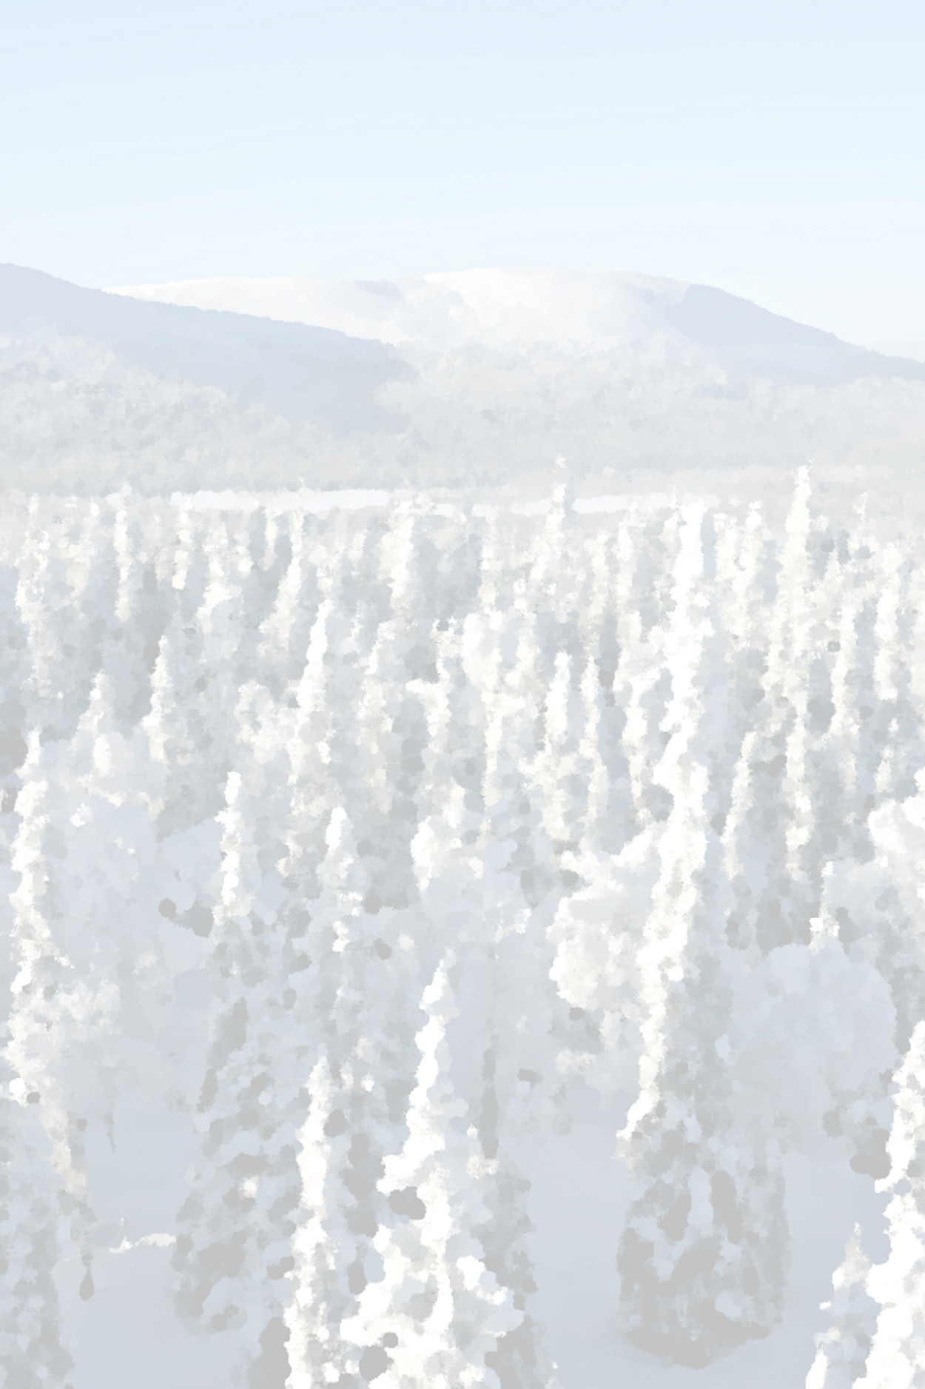
SNOWCARBO-PROJECT – 1st Stakeholder Seminar

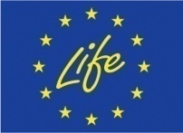
December 14th 2011,
Finnish Meteorological Institute, Helsinki, Finland

Registration 08:30-09:00
Seminar opening 09:00-09:10

Morning session 09:10-12:30

09:10 Topical issues in climate change politics (Ministry of Environment)
09:30 ICOS – greenhouse gas monitoring network (Timo Vesala, University of Helsinki)
10:00 The terrestrial carbon cycle (Gerhard Krinner, LSCE)

Coffee Break

11:15 The greenhouse gas reporting obligations set by United Nations (Tuija Lapveteläinen, Statistics Finland)
11:45 SnowCarbo – Project (Jouni Pulliainen, FMI)

Lunch break 12:30-13:30
Afternoon session 13:30-16:30

13:30 SnowCarbo- REMO-JSBACH modelling (Tiina Markkanen, Tea Thum, FMI)
14:30 Satellite data products to support climate modelling –Land Cover (Pekka Härmä, SYKE)

Coffee Break and Posters

15:15 Satellite data products to support climate modelling-Phenology & Snow Cover (Kristin Bötcher, SYKE)
15:45 Satellite data products to support climate modelling-Northern Hemispheric Snow Cover (Kari Luojus, FMI)
16:15 Dissemination (Mwaba Kangwa, FMI)

Background photo by Timo Lindholm
Discussion 16:30-17:30

Questions to be discussed

Q1: How do you see the relevance of SnowCarbo project products in terms of

- policy making
- educational
- forest management

Q2: What is the potential use of CO₂ Atlases?

Q3: What kind of CO₂ information needed and what format?

Q4: How would be results best disseminated

SnowCarbo cocktail 17:30-19:00

Registration latest on 12th December 2011 by an email to ali.nadir.arslan@fmi.fi

