LIFE Project Number
ENV/FIN/000133

3nd In-situ Data Document

Reporting Date
30/11/2011
Action
Action 5 – In situ data collection and processing by SYKE
LIFE+ PROJECT NAME or Acronym
SNOWCARBO
Olli-Pekka Mattila
Name Beneficiary | Finnish Environment Institute (SYKE)
Contact person | Olli-Pekka Mattila
Postal address | P.O.Box 140 (Mechelininkatu 34a), 00251 Helsinki
Telephone | +358-400-148 733
Fax: | +358-9-5490 2690
E-mail | olli-pekka.mattila@ymparisto.fi
Project Website | http://snowcarbo.fmi.fi

Table of Contents
List of key-words and abbreviations 2
1 Summary 3
2 New datasets from 2011 3
2.1 Operative observation networks 3
2.2 Multi-resolution observations of snow cover 3
2.2.1 AISA- imaging spectrometer 4
2.2.2 Mast based spectrometer 4
2.2.3 Field spectrometer measurements 5
2.3 Land cover data validation and reference measurements 6
3 In-situ field campaigns in 2011 6
3.1 Spring 2011 campaign 7
References 7
Annex 1 8

List of key-words and abbreviations

ASD | Analytical Spectral Devices Ltd.
AISA | Airborne spectrometer instrument by Specim Ltd.
EAGLE | Model of AISA spectrometers
FMI | Finnish Meteorological Institute
FMI-ARC | Arctic Research Center of the Finnish Meteorological Institute
Field Spec Pro | Field Spectrometer Professional (model of a measurement device)
FSC | Fractional snow cover
IFOV | Instantaneous field of view
MODIS | Moderate Resolution Imaging Spectroradiometer
SCA | Snow covered area
SCAMod | Snow covered area model – the SYKE algorithm for deriving fractional snow covered area from satellite images
SNOWCARBO | Alias for the project "Monitoring and assessment of carbon balance related phenomena in Finland and Northern Eurasia"
SYKE | Finnish Environment Institute

Summary

One additional field campaign was carried out in 2011 at the Arctic Research Centre of the Finnish Meteorological Institute (FMI-ARC) in Sodankylä in May. The focus was again in the late stages of the melting season on thinning wet snow cover and shadowed snow cover, building the spectral library further for statistical analysis.
The Sodankylä station also hosts a mast based spectral device. The instrument is the same as used in the ground based field measurements. The campaign was timed together with hyperspectral aerial imaging using AISA System by Specim – Spectral Imaging Ltd., which offers high spectral resolution (3,3nm) remote sensing imagery from the same area with high spectral resolution (1.3m). During cloudless days the MODIS- Terra satellite can provide images from the same sites in 500m resolution. These satellite images are utilized to make the interpretation of the fractional snow covered area (FSC also SCA), used for improving the carbon balance modelling. Simultaneously measurements on forest cover were measured to gather data for improving the satellite algorithm for fractional snow covered area.

New datasets from 2011

Operative observation networks
The in-situ snow course and weather station networks of SYKE and FMI, respectively, are continuing operations without major changes. Some minor changes occur on the networks on annual basis as some of the stations are ceased, the technology at the weather stations are changed and new stations are started, but the general coverage of the station networks are still extensive. Similarly, snow courses can be dropped out from the network, but overall the number of snow courses still exceeds ~100 sites.

Multi-resolution observations of snow cover
The understanding of satellite signal from large area is greatly improved when the behaviour of the signal in the sub-resolutions of the satellite images are understood. The datasets produced in SNOWCARBO in field measurements using field spectrometer (figure 1a) are complemented with measurements of the spectral signal from similar instrument, FieldSpec Pro by Analytical Spectral Devices Inc., installed in a 30m high mast Sodankylä station of the Arctic Research unit of Finnish Meteorological Institute. The area from where the signal is received is shown in figure 1b. The cooperation of FMI and SYKE, with other simultaneous activities at the Sodankylä research station have also provided access to AISA (Airborne hyperspectral camera by Specim Ltd.) imaging spectroscopy data, a sample dataset shown in figure 1c. The first three datasets allow the observations of the area under conditions where the effects of the atmosphere can be neglected. This helps in understanding and interpreting the signal from satellite sensors, e.g. MODIS- Terra (figure 1d).

Figure 1. a) Field spectrometer measurement setup; b) Digital image from the footprint of mast based ASD FieldSpec Pro; c) Sample dataset from AISA- airborne spectrometer (true colour image). Site of the mast based ASD spectrometer marked with red circle; d) Subset from MODIS- Terra image from northern Finland. Sodankylä circled with red.

AISA- imaging spectrometer

Imaging spectroscopy (or hyper-spectral remote sensing) is providing new opportunities in optical remote sensing. The introduction of dividing the visible light spectrum (including near infrared and ultraviolet) into several hundreds of bands is expanding the possibility of connecting different spectral signatures to different ground targets, when observed from remote sensing platforms (aeroplanes, helicopters, satellites etc.). The specifications of the AISA (EAGLE)- instrument, from which the data is available, are shown in Table 1:

Table 1. Specifications of the AISA (EAGLE)- hyperspectral sensor
Optical characteristics
Spectral range | 400-970 nm
Spectral resolution | 3.3 nm
Maximum numer of spectral bands | 488
Minimum spectral width of sample/band | 1.25 nm
Spatial characteristics
Instantaneous field of view (IFOV) | 29.9 degrees
IFOV/ Ground resolution @ 1000m | 0.029 degrees/ 0.52m

Mast based spectrometer

The mast based spectrometer offers opportunity to study the detailed effects of the forest canopy, without the interfering effect of the above atmosphere. The setup in Sodankylä is providing observation area with two main land cover types: sparse Scots pine forest and deforested/forest opening area covered by lichen and heather. The height and shape of the trees, the density and structure of the forest stand together with changing illumination conditions create complex path for light transmission through forest canopy. Understanding the effects of individual processes helps to interpret the satellite signal. The instrumentation is described in detail in (Action 4 deliverable – 2nd Data Document)

Work carried on the mast spectrometer data, outside the SNOWCARBO (PhD work by Kirsikka Niemi), is providing results that have provided useful information on the following themes:

- Sensitivity of the spectrum of light reflected from directly and diffusely (in shadowed snow cover) illuminated surfaces
- Sensitivity of the spectrum of light to surface snow characteristics (impurities, liquid water content, illumination geometry and grain size)
- Leading to differences in at-instrument reflectances from different land cover types: sparse Scots pine forest and deforested area covered by lichen and heather.

Important findings
- Snow scatters more in forward direction vs. vegetation scatters more in backward direction
- Forest canopy backscatter dominates the signal even when the forest has only 40% crown coverage
- Reduction of snow reflectance with increasing snow grain size, irrespective of illumination conditions.

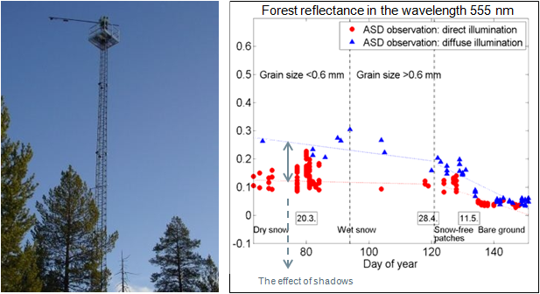
From work by Kirsikka Niemi
Figure 2. Image of the mast-based spectrometer measurement setup (left). Measurements of forest reflectance at 555nm wavelength (right).

Field spectrometer measurements
The measurements with the field spectrometer, where now carried out in conjunction with measurements of airborne sensor AISA and master-based spectrometer measurements. The most detailed level of measurements in the chain of information sources from ground measurements to the satellite images are done only ~30-50 cm away from the surface, with the same instrumentation as in the mast based measurements. This gives the detailed characteristics of spectrum under different snow conditions. The measurements of snow spectrum were continued in spring 2011 and the focus was the shadowed snow cover as well as the thin snow layers, when the understory vegetation starts to influence the reflectance signal. Similar measurements were carried out also in spring 2010, but for statistically sound treatment of the spectral signatures more spectral observations were acquired.

Land cover data validation and reference measurements
The SCAmod method for deriving fractional snow cover from optical satellite images was developed in order to make interpretation for forested regions, where the snow surface is only partly visible to the satellite through the trees. Currently the methodology is assumes near-nadir viewing angle of the satellite. The accuracy of the method has been described in (Metsämäki et al, 2005 and Salminen et al., 2008) showing that the standard error for the method is between 5-7 %-units in the estimation of the fractional snow covered area. This accuracy is also related to the error in the viewable gap fraction through the trees due to different satellite viewing angles.

More slanted viewing angles produce different geometry for satellite observations of forests. The gaps, through which the snow covered terrain is seen, are greatly reduced as the viewing increases relative to the nadir. The situation is analogous to estimating the albedo for different sun zenith angles (Lohila et al., 2010). To make an estimation of the gap fraction seen through different viewing angles of satellite instrumentation the following forest parameters were measured in observation areas of the Sodankylä research station:

Measured:
- Mean width of tree crown cover
- Mean height of the crown base
- Forest stand basal area
- Mean diameter of trees
- Mean height of trees

From these parameters the following forest stand parameters can be estimated:
- Percentage of crown cover (Korhonen et al., 2007)
- Stem volume (Zianis et al., 2005)
- fractional cover with viewing zenith angle 45-60° (Lohila et al., 2010)

In-situ field campaigns in 2011

Late spring in Scandinavia is often difficult time for field measurements of reflectance spectrum. Frequent low pressure systems bring moisture and cloud cover over Scandinavia and therefore inhibit the measurements. When the objective of the field measurements is to capture spectral properties from thinning snow cover the luck with the weather plays a major role with current measurement setup. An additional field campaign was carried out at the FMI Sodankylä research station. The measurements were conducted in conjunction with other activities in the area. Additionally to measurements of reflectance properties of snow, forest parameters were estimated to evaluate their significance for the optical pathways seen through the view of remote sensing instruments.

Spring 2011 campaign

Spring 2011 campaign was carried out between 2nd and 6th of May. Main objectives were:
- Complement the spectral reflectance library with measurements from thinning and wet snow cover, including the related snow pit measurements
- Estimate forest parameters to evaluate the influence of satellite view angle on the estimation of snow properties, due to differences in forest coverage

Spectrometer measurements

The weather conditions were favourable for the spectrometer measurement on 6 days with 8 sites measured for optical and physical snow properties. The measurements were carried out in conjunction with AISA over flights and mast based spectrometer measurements in the research area.

Forest parameters for satellite observations

A set of field sample plots were measured in Sodankylä area during measurement campaign May 2011. Locations of plots were defined according to flight lines of air-borne measurements and instrumentation of Tähtelä observatory. Altogether 41 sites were measured for forest parameters. The sites are shown in on the map in Figure 3 and the measured variables and estimated variables are listed in Annex 1.

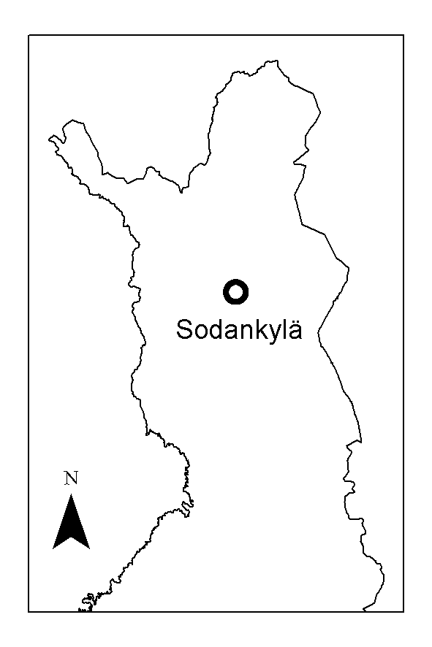
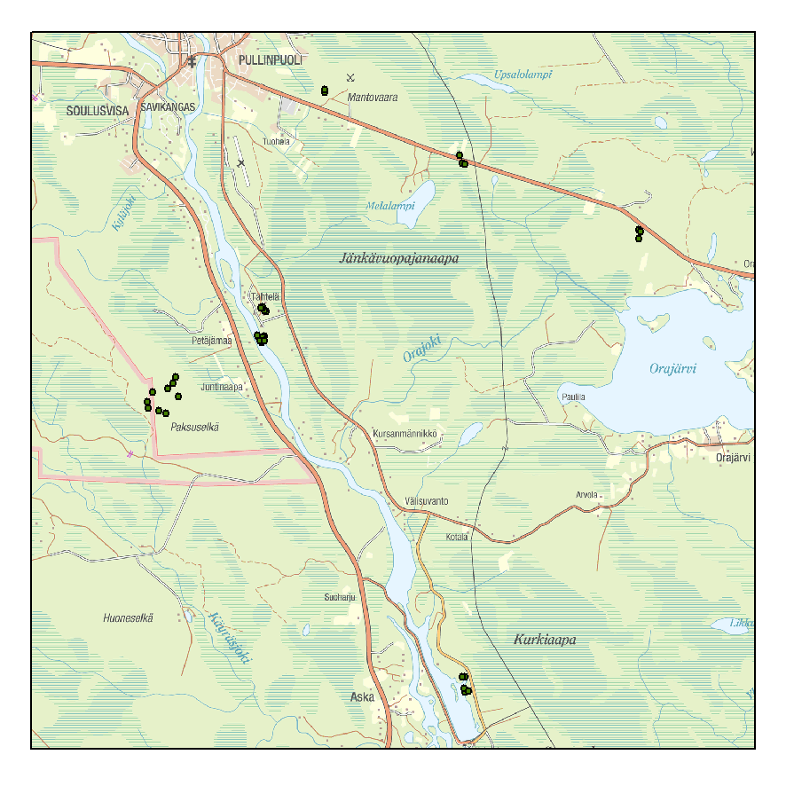
Figure 3. Map marking the forest plots measured for reference of mast based spectrometer and airborne AISA measurements.

References

Korhonen, L., Korhonen, K.T., Stenberg, P., Maltamo, M. & Rautiainen, M. 2007. Local models for forest canopy cover with beta regression. Silva Fennica 41(4): 671–685.

Lohila, A., K. Minkkinen, J. Laine, I. Savolainen, J.-P. Tuovinen, L. Korhonen, T. Laurila, H. Tietäväinen, and A. Laaksonen (2010), Forestation of boreal peatlands: Impacts of changing albedo and greenhouse gas fluxes on radiative forcing, J. Geophys. Res., 115, G04011, 15 p.

Zianis, D., Muukkonen, P., Mäkipää, R. & Mencuccini, M. 2005. Biomass and stem volume equations for tree species in Europe. Silva Fennica Monographs 4. 63 p.

Annex 1
Table 2 Measurement sites and measured and estimated variables from the forest plots.
ID | Lat (°) | Long (°) | Width of  crown (m) | Height of crown base (m) | Basal area (m²/ha) | % of brd. Leaf trees | Diameter (cm) | Tree height (m) | Age (y) | Crown cover (%) | Gap fraction (45-60°) | Stem volume (m³/ha) | Stems per ha | Crown height/ cr width
1 | 67.36178 | 26.63506 | 3.4 | 7.8 | 25 | 0.0 | 18.0 | 15.4 | 60 | 58.7 | 73.8 | 188.6 | 1050 | 2.2
3 | 67.36155 | 26.63483 | 7.6 | 5.0 | 12 | 0.0 | 34.8 | 18.9 | 150 | 26.5 | 38.8 | 108.0 | 126 | 1.8
4 | 67.36127 | 26.63445 | 4.9 | 9.0 | 7 | 0.0 | 30.0 | 16.5 | 150 | 17.6 | 26.9 | 56.2 | 100 | 5.3
5 | 67.36106 | 26.63415 | 4.8 | 8.0 | 18 | 0.0 | 27.9 | 17.8 | 150 | 41.9 | 57.0 | 153.8 | 320 | 2.0
6 | 67.36141 | 26.63285 | 4.6 | 8.3 | 16 | 0.0 | 25.4 | 16.6 | 60 | 39.5 | 54.3 | 129.2 | 380 | 1.8
7 | 67.36164 | 26.63466 | 3.6 | 7.6 | 22 | 0.0 | 18.5 | 13.9 | 60 | 56.5 | 71.7 | 151.9 | 870 | 1.7
8 | 67.36171 | 26.63440 | 3.1 | 5.2 | 26 | 0.0 | 14.0 | 12.2 | 60 | 65.3 | 79.6 | 160.5 | 1920 | 2.3
9 | 67.36069 | 26.63410 | 5.2 | 8.3 | 17 | 0.0 | 21.0 | 16.8 | 75 | 41.5 | 56.5 | 138.1 | 520 | 1.6
10 | 67.36195 | 26.63191 | 2.8 | 9.5 | 12 | 0.0 | 17.0 | 16.3 | 75 | 30.3 | 43.5 | 95.0 | 590 | 2.4
11 | 67.36096 | 26.63305 | 5.4 | 8.0 | 17 | 0.0 | 26.0 | 19.5 | 75 | 36.9 | 51.4 | 156.8 | 350 | 2.1
12 | 67.36093 | 26.63538 | 5.7 | 7.4 | 15 | 0.0 | 29.3 | 19.4 | 75 | 32.7 | 46.5 | 137.7 | 223 | 2.1
13 | 67.35407 | 26.59173 | 2.2 | 8.5 | 15 | 0.0 | 14.0 | 14.1 | 55 | 41.4 | 56.4 | 104.8 | 1140 | 2.5
14 | 67.35279 | 26.59042 | 3.0 | 6.3 | 13 | 0.0 | 18.0 | 13.8 | 49 | 36.8 | 51.3 | 89.1 | 560 | 2.5
15 | 67.35026 | 26.59309 | 3.4 | 8.3 | 11 | 0.0 | 16.0 | 14.8 | 48 | 29.9 | 43.1 | 80.1 | 630 | 1.9
16 | 67.34715 | 26.58728 | 3.8 | 4.5 | 12 | 0.0 | 22.0 | 15.3 | 75 | 31.8 | 45.4 | 90.0 | 340 | 2.8
17 | 67.34764 | 26.58347 | 4.3 | 6.3 | 14 | 7.1 | 22.3 | 16.4 | 75 | 37.8 | 52.4 | 111.5 | 400 | 2.4
18 | 67.34815 | 26.57837 | 3.4 | 4.3 | 12 | 0.0 | 19.0 | 13.5 | 75 | 34.5 | 48.6 | 80.9 | 460 | 2.7
19 | 67.34928 | 26.57799 | 2.8 | 3.8 | 11 | 18.2 | 13.9 | 10.1 | 55 | 44.1 | 59.3 | 57.2 | 850 | 2.3
20 | 67.35103 | 26.58031 | 2.0 | 5.0 | 11 | 0.0 | 15.0 | 13.5 | 55 | 31.8 | 45.3 | 74.2 | 720 | 4.3
21 | 67.35183 | 26.58780 | 3.6 | 9.8 | 12 | 0.0 | 25.0 | 19.5 | 70 | 25.7 | 37.8 | 110.7 | 244 | 2.7
22 | 67.36658 | 26.63604 | 2.8 | 7.8 | 17 | 0.0 | 16.0 | 14.5 | 50 | 45.4 | 60.7 | 122.0 | 950 | 2.4
23 | 67.36667 | 26.63523 | 3.2 | 6.8 | 19 | 0.0 | 19.0 | 14.8 | 55 | 49.3 | 64.7 | 138.4 | 710 | 2.5
24 | 67.36716 | 26.63411 | 2.4 | 7.5 | 19 | 0.0 | 14.0 | 13.3 | 55 | 51.9 | 67.3 | 126.1 | 1420 | 2.4
25 | 67.36741 | 26.63429 | 3.0 | 6.0 | 19 | 0.0 | 20.0 | 14.5 | 55 | 49.7 | 65.1 | 136.4 | 640 | 2.8
26 | 67.36720 | 26.63354 | 3.6 | 7.0 | 14 | 0.0 | 21.0 | 14.5 | 55 | 38.1 | 52.8 | 100.5 | 430 | 2.1
27 | 67.29488 | 26.73452 | 3.0 | 6.0 | 18 | 0.0 | 18.0 | 16.0 | 54 | 45.1 | 60.4 | 140.6 | 770 | 3.3
28 | 67.29466 | 26.73438 | 7.0 | 7.8 | 17 | 5.9 | 28.0 | 16.8 | 75 | 43.9 | 59.1 | 138.1 | 300 | 1.3
29 | 67.29527 | 26.73405 | 3.2 | 13.0 | 25 | 0.0 | 19.0 | 19.0 | 54 | 52.5 | 67.9 | 225.7 | 920 | 1.9
30 | 67.29485 | 26.73626 | 4.8 | 7.8 | 10 | 0.0 | 26.0 | 15.5 | 80 | 26.3 | 38.5 | 76.0 | 188 | 1.6
31 | 67.29758 | 26.73435 | 6.0 | 6.8 | 17 | 23.5 | 28.0 | 18.5 | 75 | 47.8 | 63.2 | 150.1 | 300 | 2.0
32 | 67.29752 | 26.73304 | 5.6 | 9.5 | 18 | 5.6 | 25.0 | 16.8 | 80 | 46.0 | 61.3 | 146.2 | 390 | 1.3
33 | 67.39630 | 26.73095 | 2.8 | 3.5 | 8 | 37.5 | 11.0 | 9.5 | 40 | 42.4 | 57.5 | 39.4 | 1100 | 2.1
34 | 67.40813 | 26.66419 | 3.8 | 12.8 | 13 | 0.0 | 22.0 | 20.3 | 100 | 26.9 | 39.3 | 123.7 | 370 | 2.0
35 | 67.40868 | 26.66416 | 4.0 | 12.0 | 13 | 0.0 | 22.0 | 21.0 | 100 | 25.9 | 38.0 | 127.4 | 370 | 2.3
36 | 67.38059 | 26.81902 | 1.8 | 5.3 | 11 | 0.0 | 15.0 | 14.0 | 50 | 31.0 | 44.4 | 76.6 | 720 | 4.9
37 | 67.39484 | 26.73234 | 2.2 | 5.0 | 11 | 0.0 | 11.0 | 10.3 | 36 | 36.8 | 51.3 | 58.0 | 1500 | 2.4
38 | 67.39456 | 26.73339 | 3.6 | 4.8 | 13 | 23.1 | 17.0 | 13.0 | 40 | 46.9 | 62.2 | 84.8 | 630 | 2.3
40 | 67.38239 | 26.81921 | 2.8 | 4.8 | 10 | 0.0 | 14.0 | 12.0 | 48 | 31.2 | 44.6 | 60.8 | 770 | 2.6
41 | 67.38195 | 26.81985 | 4.2 | 4.0 | 16 | 0.0 | 16.0 | 13.0 | 45 | 45.6 | 60.9 | 104.4 | 900 | 2.1

